
Peacemaking Circle Training

(2 ½ day training)

February 9 and 10 with a half day follow-up on March 8, 2012

Registration: 8:30 AM *** Training: 9 AM to 3 PM (Feb. 9 & 10)
March 8th (9 AM – Noon)

Register Early – Training is limited to 15 participants!

Preference will be given to AODA Consortium School Districts: Bayfield,

Butternut, Chequamegon, Mellen, Mercer, Solon Springs and Washburn.

Overview
Peacemaking Circles and Talking Circles are a structured process used to bring people together to better understand one another, build and strengthen bonds and solve community problems. Talking Circles and Peacemaking Circles provide a way for people to have conversations and to work through conflict or differences in a safe and productive way.
The Talking Circle and Peacemaking Circle process is used for: building, strengthening and deepening relationships within a small group, classroom/community/family, repairing harm, conflict resolution, classroom activities, student/staff dynamics, parent teacher conferences, staff meetings, teaching in the classroom, IEP meetings, as an option to suspension and expulsion, exit meetings and re-entry meetings related to suspension, inter-agency communication, and win-win situations.
This training will give you the opportunity to learn Peacemaking Circles experientially. We will explore core values and clarify what is truly important to us.
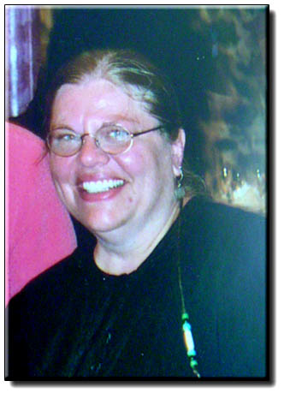

Presenter: Jamie Williams is a Restorative Justice/Measures Consultant, Trainer, Teacher and Circle Keeper. She holds a BA from Metropolitan State University in Human Services: Counseling and Intervention and an MA Degree from St. Mary’s University in Human Development.

Wisconsin State Performance Plan Indicators & Standards Addressed

Wisconsin's State Performance Plan Indicators: 1, 2. 4. 5
Wisconsin Teacher Standards Addressed: 2, 3, 5, 6
Wisconsin Pupil Services Standards Addressed: 2, 3, 5, 6, 7
Wisconsin Administrator Standards Addressed: 2, 3, 5, 7
PBIS Tier 1 and Tier 2

Target Audience
Regular and Special Education Teachers, Guidance Counselors, Principals, School Psychologists

Registration Fee for AODA Consortium Districts: (Bayfield, Butternut, , Mellen, Mercer, Solon Springs and Washburn)

$30 per participant for the 2-½ day training.

Registration Fee for Non AODA Consortium Districts:
$150 per participant for the 2-½ day training

Registration fee includes materials, breaks and lunch
Deadline for Registration
February 2, 2012
Viterbo Credit Pending
Please register on: www.myquickreg.com

